Lab 14: Data Encoding
Course Name: Malware Analysis and Reverse Engineering (IAM302)
Student Name: Nguyễn Trần Vinh – SE160258
Instructor Name: Mai Hoàng Đỉnh
Lab Due Date: 29/2/2023

Purpose
You will practice the techniques in chapter 13

What you need:
- A Windows machine with the tools we have been using installed.

Beacons
- The book recommends running the malware with another VM simulating the Internet with inetsim, but I don't see any good reason to bother with that. I just connected a VM to the real Internet and ran the malware.

Launch the Lab13-01.exe file
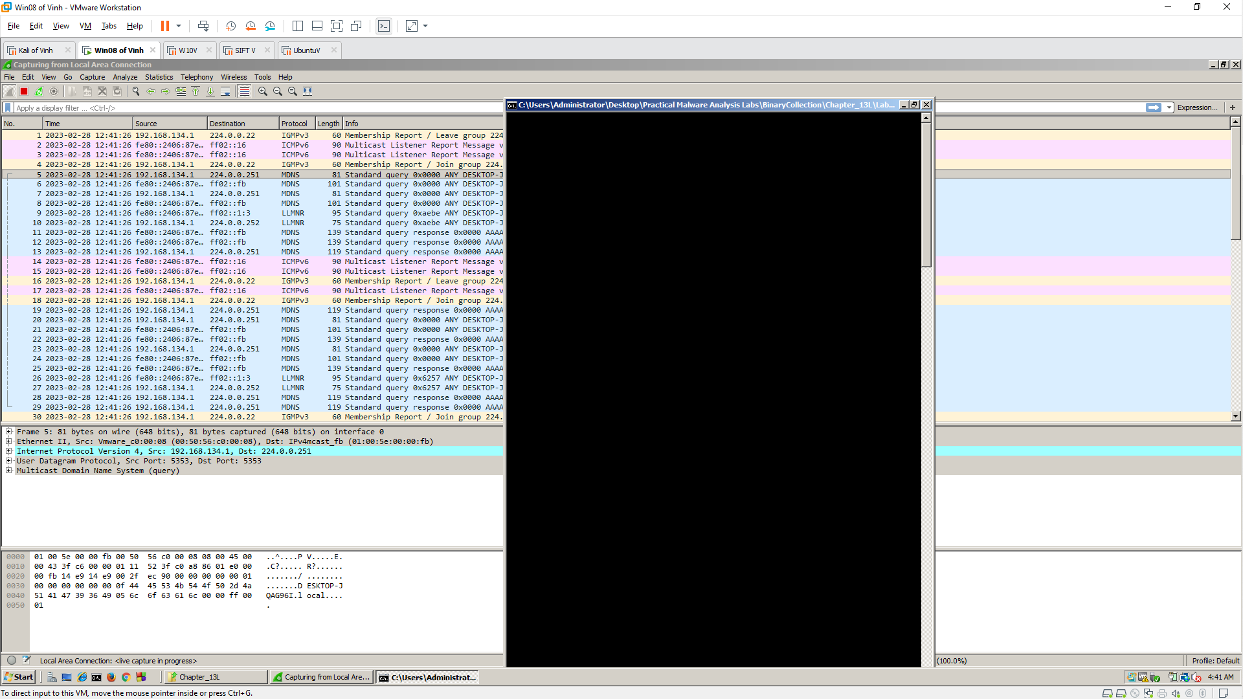

Wireshark
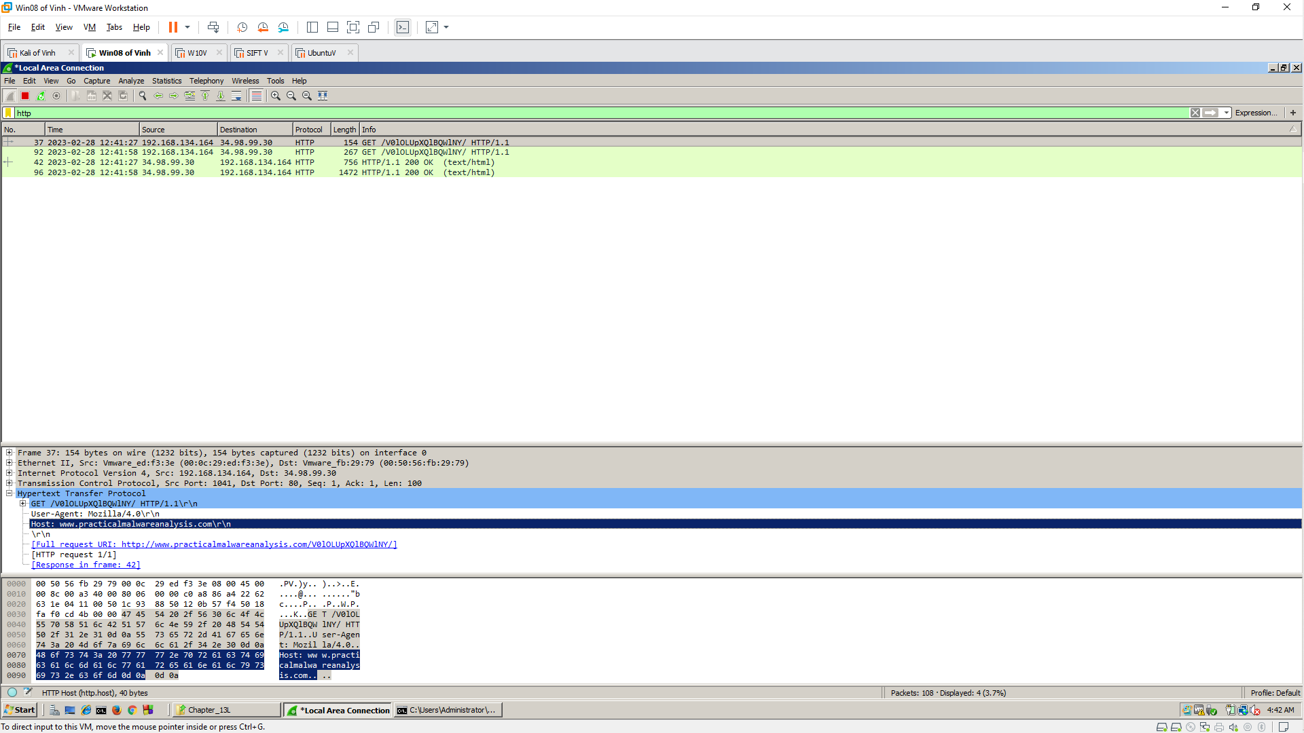

Strings
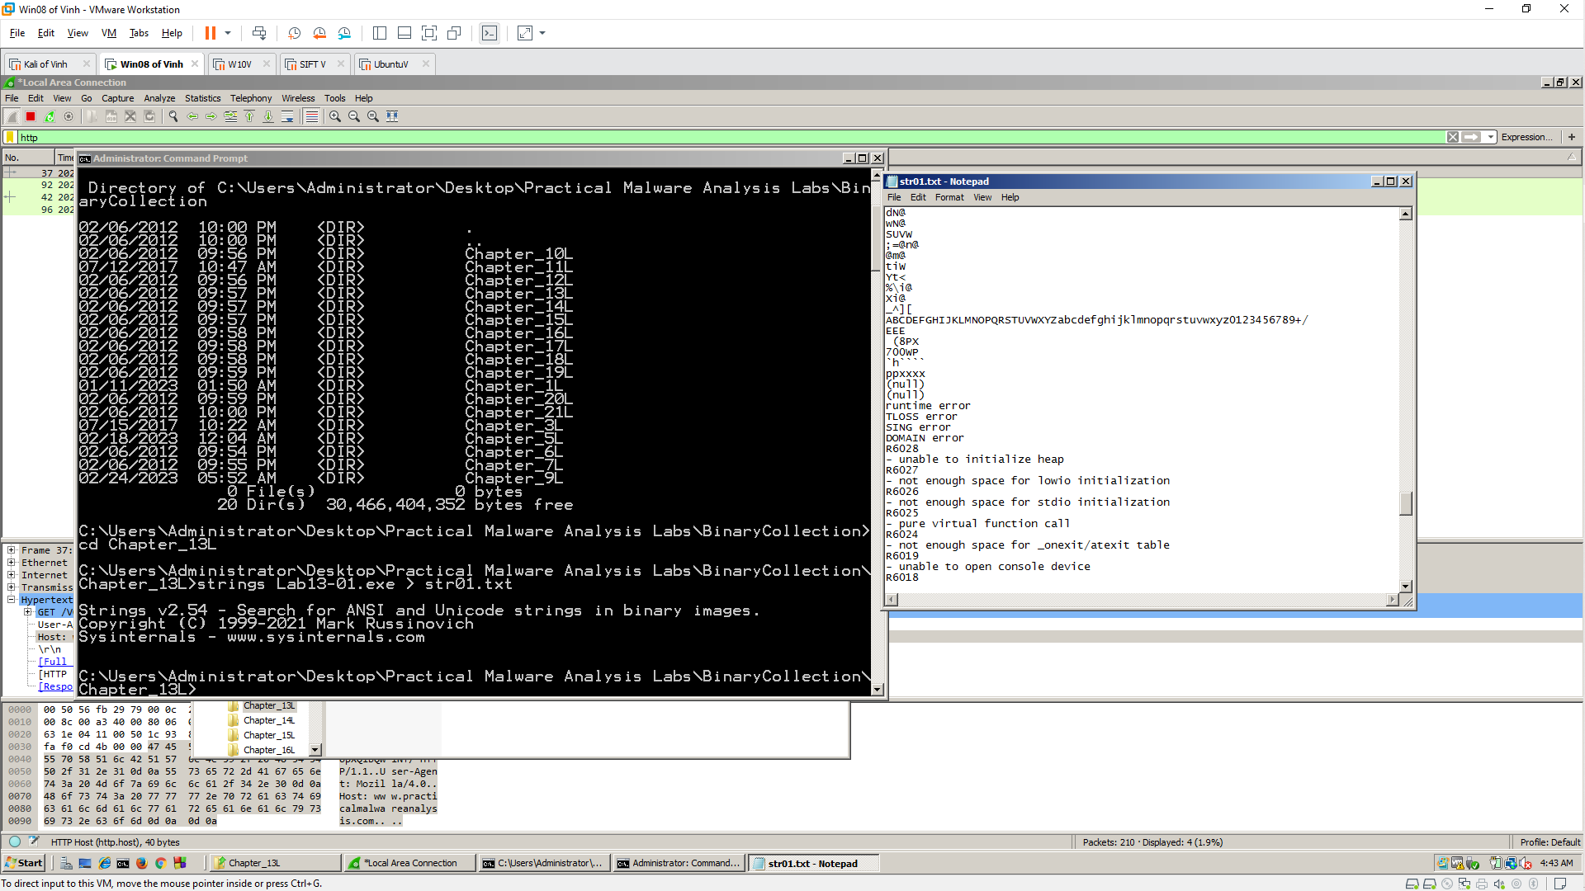

IDA Pro
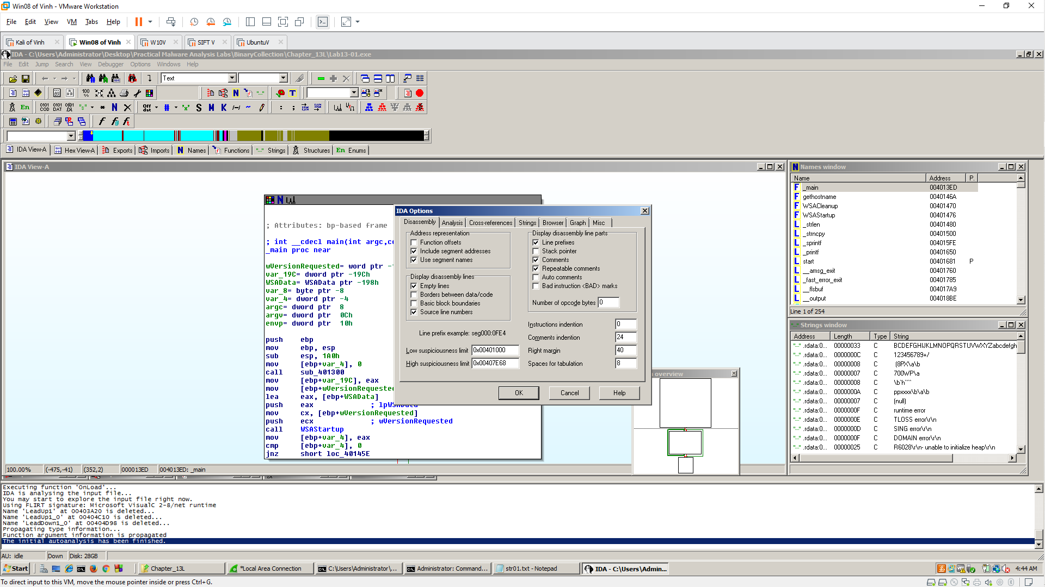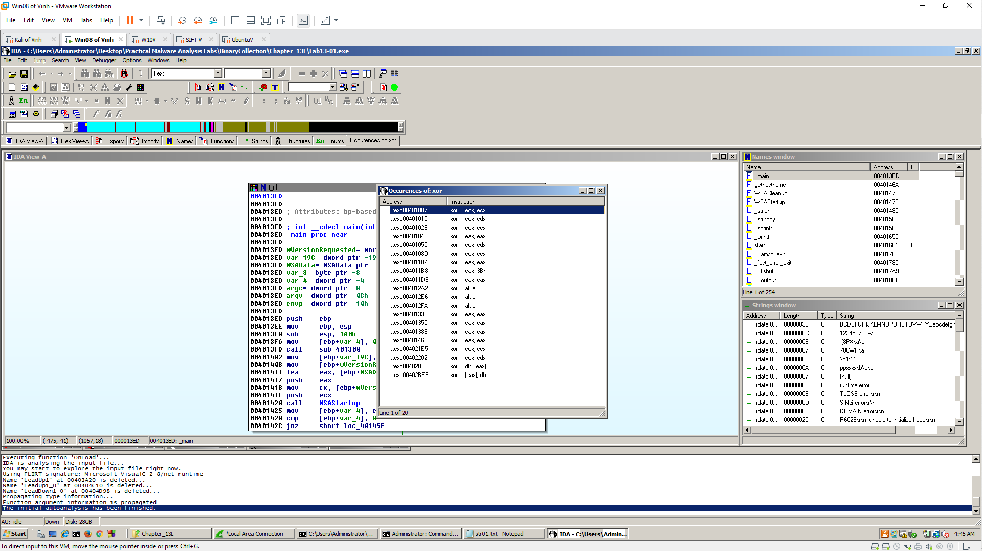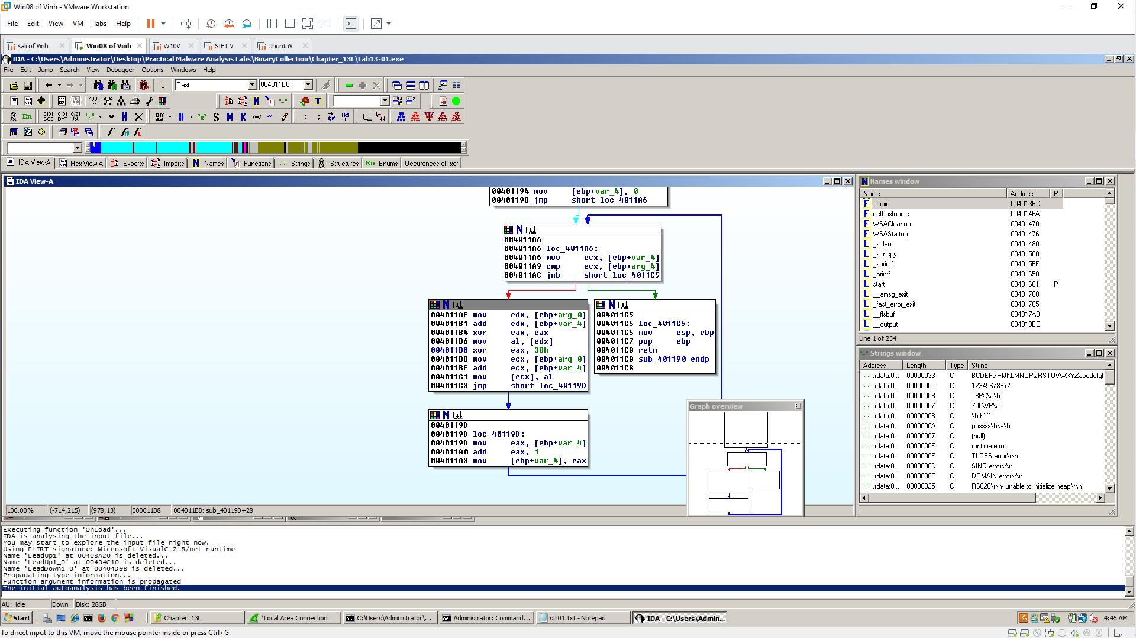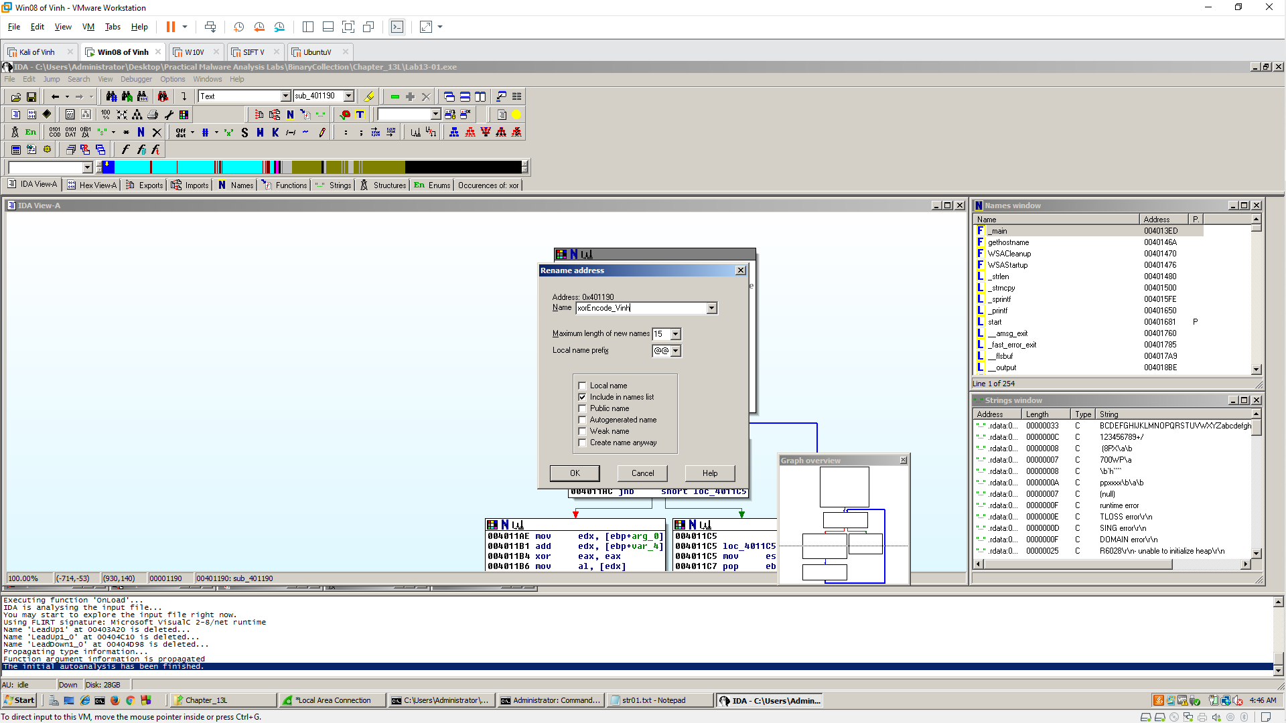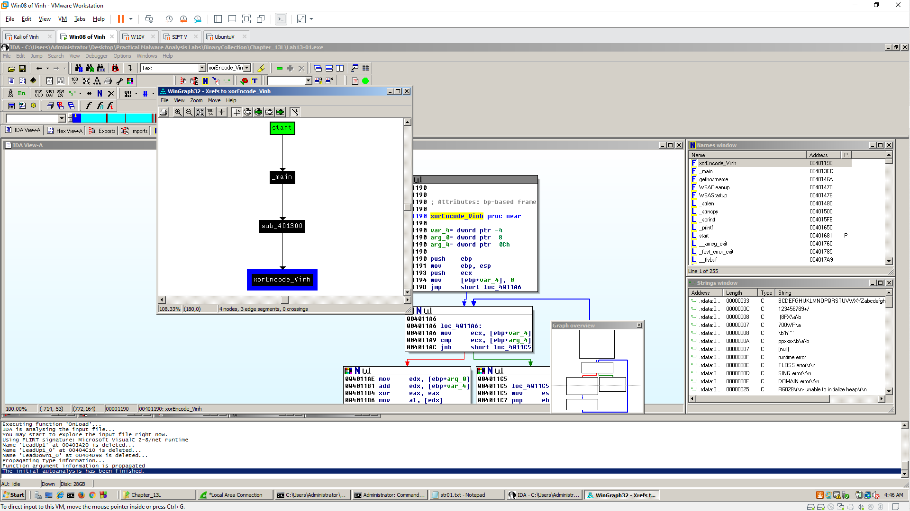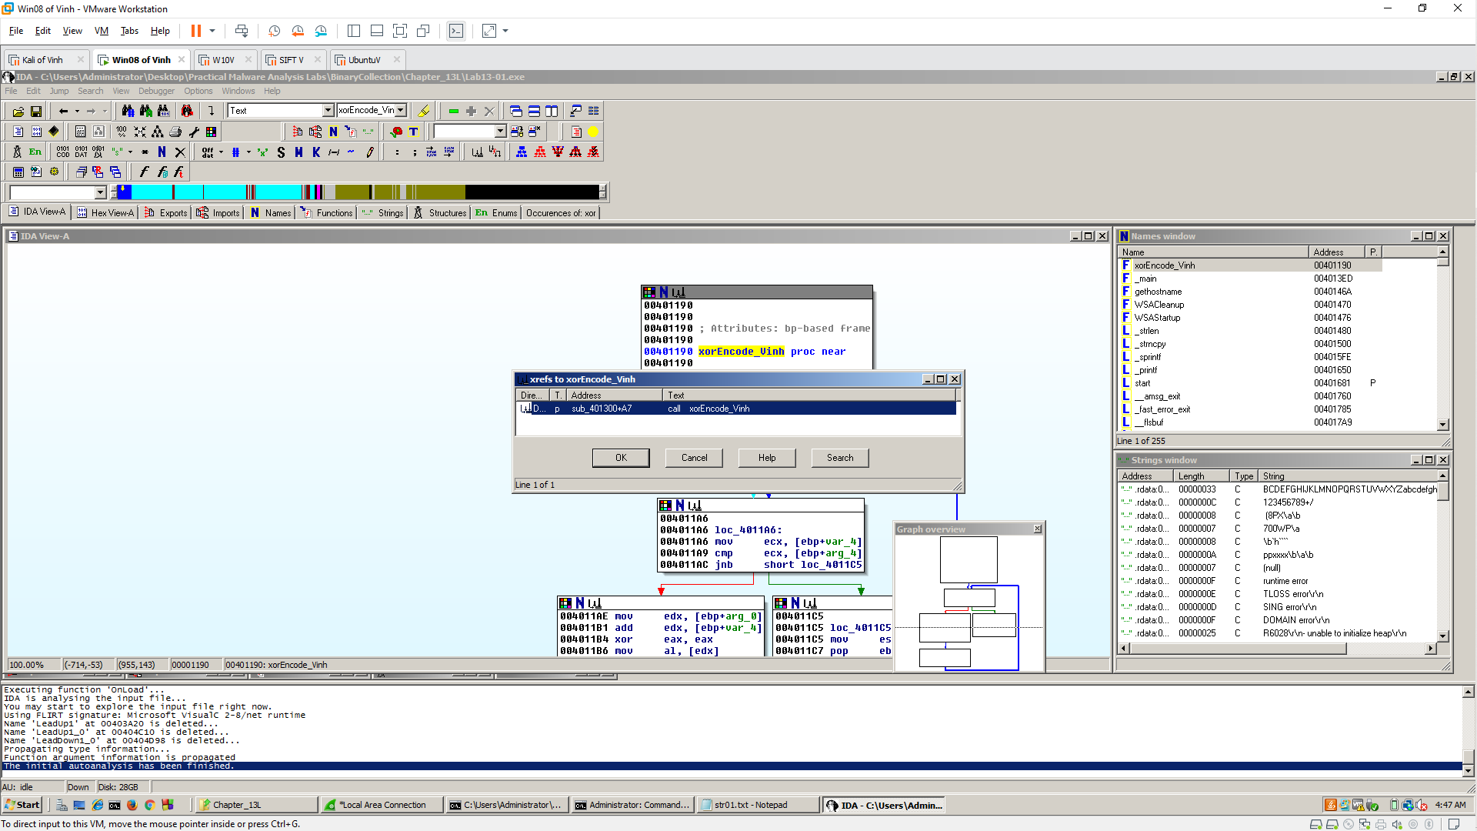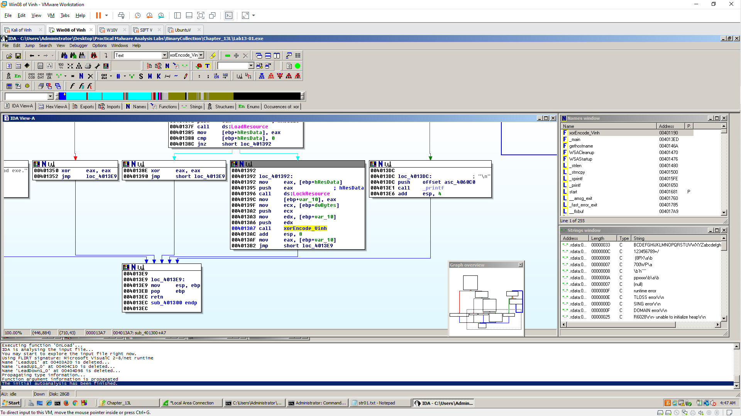

PEview
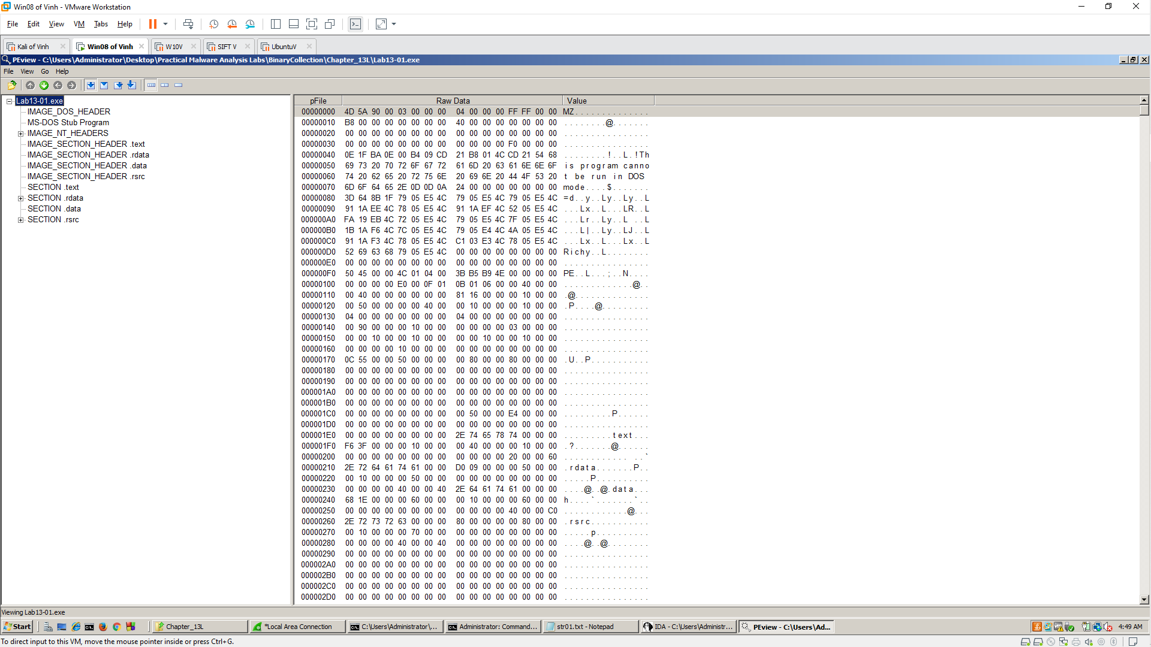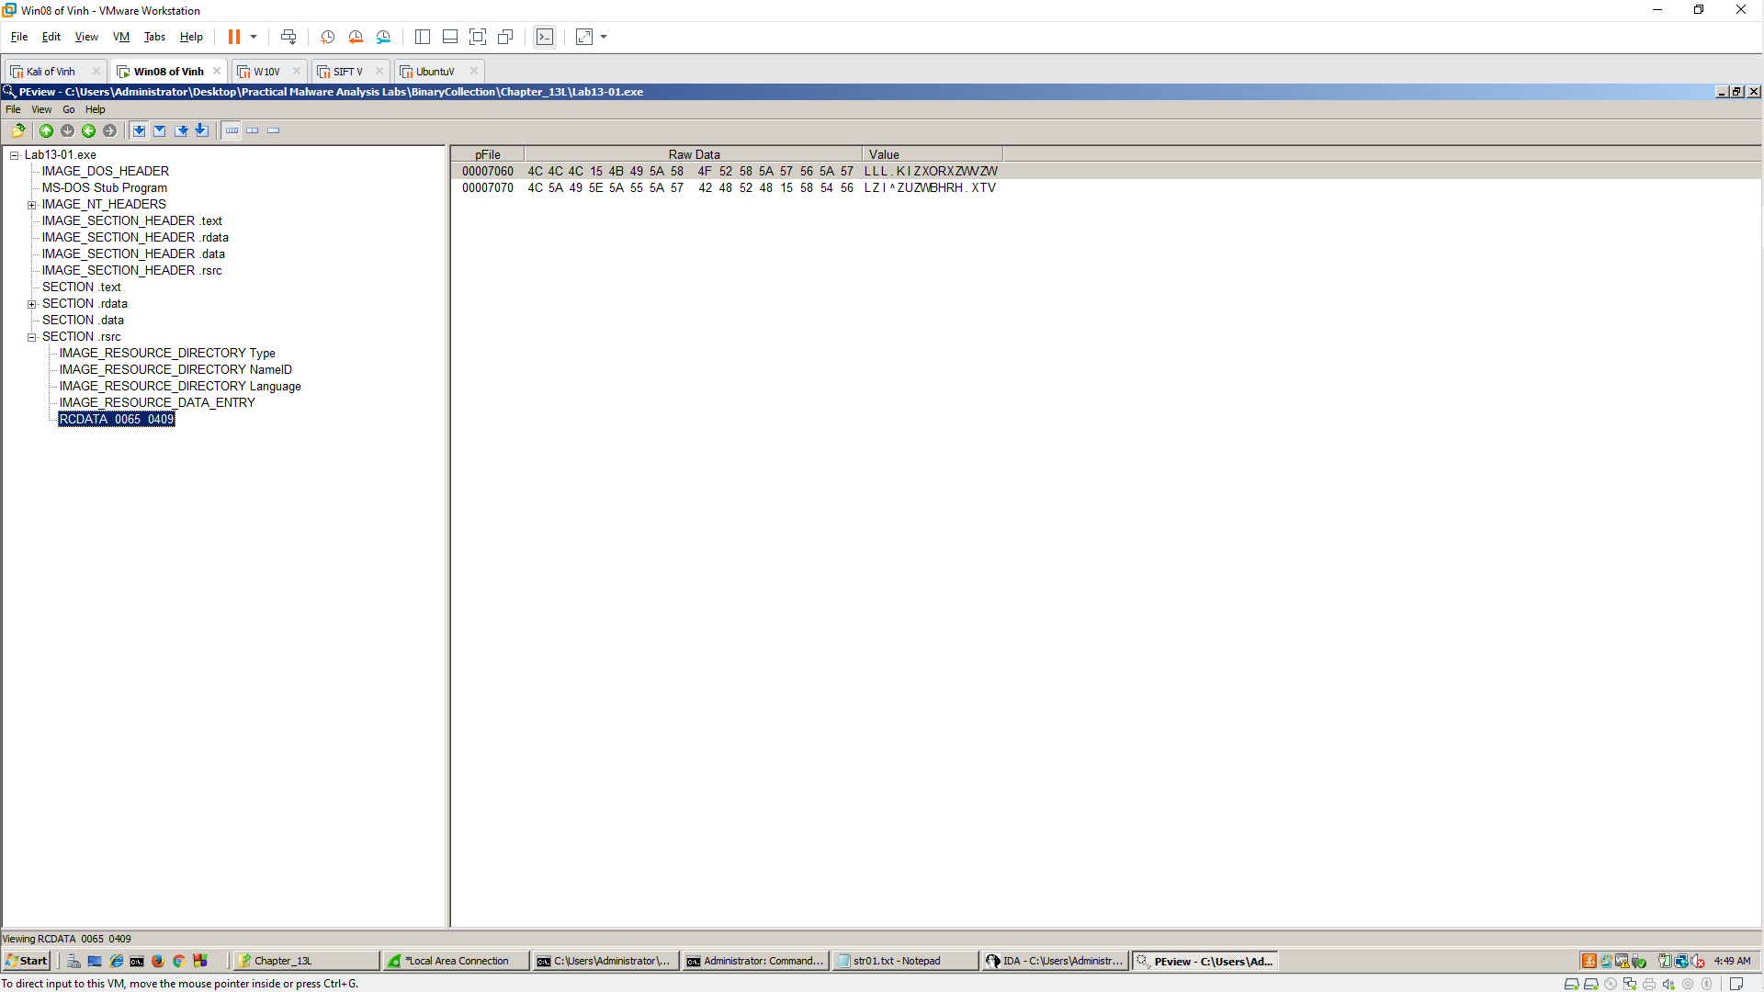

WinHex
